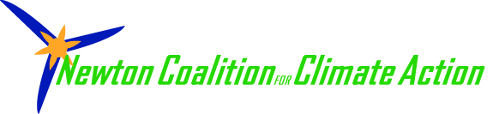

*Greetings friends and neighbors,*

***Did you know this fall your electricity will   
be sourced through a new city program?***

*Newton Power Choice, is a form of group electricity purchasing for residents and businesses in Newton. The City will be making decisions about the renewable content of this contract, offering options for participation and for opt-out. It will also provide a way to buy more New England wind and solar power.*

*Please join me to hear about how we can* ***green our electric grid****.*

*Date:*

*Time:*

*Address:*

***We know with a higher renewable component we can:***

*• Reduce demand for dirty fossil fuels  
• Protect our health  
• Create local jobs  
• Keep billions of dollars in Massachusetts*

*Come hear about Newton Power Choice and the   
Newton Coalition for Climate Action 40% More Green Campaign*

*I promise it will be worth your while.*

*Refreshments and good company!*

*RSVP: Name and email*